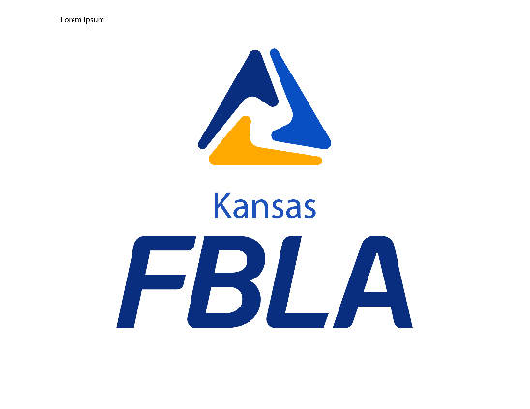

Kansas Future Business Leaders of America

State Officer Application Packet

2023-2024

Thank you for your interest to serve Kansas FBLA Collegiate by running for a State Office position.

This Packet includes:
- State Officer Application 2023-2024
- State Officer Code of Conduct and Commitment to Responsibilities
- Code of Conduct Form

2020-2021 Kansas FBLA Collegiate State Officer Application Form
Name
Office Applying For (circle one) President Vice President Secretary Treasurer
Communications Officer Parliamentarian
Date You Became an Active FBLA Member
School
Address While at School
Personal Information:
Grade in School
Major
Home Address
Birthday
Cell Phone Number
Email Address
FBLA Information
Adviser(s) Name(s)
Adviser’s Email Address
Adviser’s Cell Phone Number
Please list the local, district, regional, state and/or national FBLA and/or FBLA offices you have held or currently hold with number of years.

________________________________________________________________________________________________________________________________________________________________________________________________________________________________________________________________________________________________________________________________________________________________________________________
List business/business related courses taken or currently enrolled in during high school and college:
__________________________________________________________________________________________________________________________________________________________________________________________________________________________________________________________________________________________

On the next few pages of this document, please answer all the following questions.
- Why do you wish to serve as a Kansas FBLA officer?
- List your activities involved in within FBLA (committees served, honors won, chapter participation, conferences attended, etc.).
- List your activities in other youth, civil, social, class, or church groups (include offices held, honors won, etc. [please limit this section to collegiate activities]).
- What are your career plans?

This application form along with your signed code of conduct, and, resume should be emailed by Friday, April 14, 2023 to: Janice Akao

Ms. Janice Akao, State Adviser
Kansas FBLA Collegiate
jakao@butlercc.edu

Question 1: Why do you wish to serve as a Kansas FBLA Collegiate officer? What new ideas would you bring to the board?

Question 2: List your activities involved within FBLA.

Question 3: List your activities in other youth, civil, social, class, or church groups.

Question 4: What are your career plans?

State Officer Code of Conduct and Commitment to Responsibilities

Expectations:

While representing FBLA. . .

1. I shall behave in a courteous and respectful manner, per the national and state FBLA guidelines, refraining from language and actions that might bring discredit upon the FBLA association.

2. I shall fully participate in all appropriate FBLA activities, conferences, workshops, business meetings, etc. for which I have responsibility unless excused by the State Adviser and State Board. This includes, but not limited to, Officer Orientation Meeting, National Leadership Conference, Fall Leadership Conference, National Fall Leadership Conference, and the State Leadership Conference. Written notification (e-mail will be accepted) must reach State Adviser one week before the intended absence. After the first unexcused missed event, the state officer will receive a warning. The second unexcused event will result in a review by the Board with the strongest punishment being dismissal by the Board.

3. I shall abide by the prescribed association dress code.

4. I shall be willing to take and follow instructions as directed by those responsible and meet all deadlines set for me.

5. I shall treat all members equally.

6. When participating in FBLA assignments, I shall not damage or deface property. I will pay for any damages caused by me to any property or furnishings in hotel rooms, private accommodations and/or buildings.

7. I shall communicate any circumstances which prevent me from carrying out predetermined assignments to appropriate personnel or when personnel cannot be contacted to the President.

8. I realize that I am not permitted to wear any campaign materials at the State Leadership Conference except when campaigning for myself.

9. I shall avoid places and actions that in any way could raise questions as to moral character or conduct.

10. I shall not be in possession of or consume controlled substances.

11. I shall not violate any state or federal laws.

A violation of items 9-11 will result in immediate suspension by the State Adviser followed by a hearing in front of the State Board within 10 days. The State Executive Board may act up to and including expulsion from the State Board. Due process, as it is outlined below, shall be followed. While under suspension, the accused will be unable to participate in any FBLA activities, officer duties, Board voting session or executive sessions.

Due Process:

1. While undergoing the hearing process, the accused party will be suspended from all duties until actions are taken.

2. The State Executive Board will bring charges against an individual only upon approval of the charges, by the majority of the Board and the State Adviser.

3. The State Adviser has the authority to veto the decision of the State Board to bring charges against an individual if he or she feels the charges are frivolous or unsubstantial.

4. The State Adviser, in cooperation with the local school and FBLA authorities shall conduct investigations, including gathering facts from involved parties and witnesses.

5. Following a hearing, based on a study of facts, the Executive Board will make final determination of guilt or innocence and will take appropriate actions.

Hearing Process:

1. The State Executive Board will sit as a deliberative assembly with the State President presiding. Any Board members charged with an infraction(s) shall not sit in Deliberative Assembly.

2. The State Adviser shall act as the prosecuting party.

3. The accused shall be allowed the opportunity to defend themselves or may retain their local adviser as counsel.

4. Deliberation shall be conducted in executive session with the State Adviser.

5. When a verdict is reached, the accused shall be immediately notified of the actions being taken.

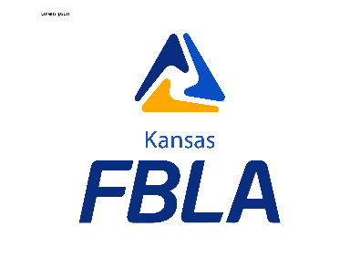

Code of Conduct Form

This form will be completed by all members applying for a Kansas FBLA state office.

If elected to the Kansas FBLA Collegiate State Board, I agree that I will abide by the prescribed Code of Conduct and the FBLA Bylaws, and I accept all the responsibilities associated with my office as dictated by the Kansas FBLA Collegiate Bylaws. By signing below I acknowledge everything above, and confirm everything listed in my application, campaign materials, and campaign speech is correct and truthful.

__________________________________________________________________
(Signature of student) (Date)

If elected/selected to a State Office in Kansas Collegiate FBLA, the above-mentioned student will receive the full support and endorsement of the local FBLA chapter and local adviser(s) in the execution of the duties of this office and commitment to the Kansas FBLA Code of Conduct.

__________________________________________________________________
(Signature of local FBLA adviser) (Date)

Please return this signed form with the other State Officer Application materials to
State Adviser, Janice Akao.

